

American International University-Bangladesh (AIUB) **SOFTWARE ENGINEERING**

**Section: F**

**PROJECT TITLE : EMERGENCY AUTOMOBILE TECHNICIAN SERVICE (MACHANIC KOTHAY?)**

**Group : 07**

**Submitted by:**

|  |  |
| --- | --- |
| **Name** | **ID** |
| 1. TAZRIAN ZAMAN TUSHTI | 19-39433-1 |
| 1. KHANDAKER MD. TOUSIF ISLAM | 19-39407-1 |
| 1. HASAN, SHADIK | 19-39357-1 |
| 04. AFIQUE SADIQUE | 19-39708-1 |

**Submitted to:**

**Dr. Razib Hayat Khan**

**CLASS DIAGRAM:**

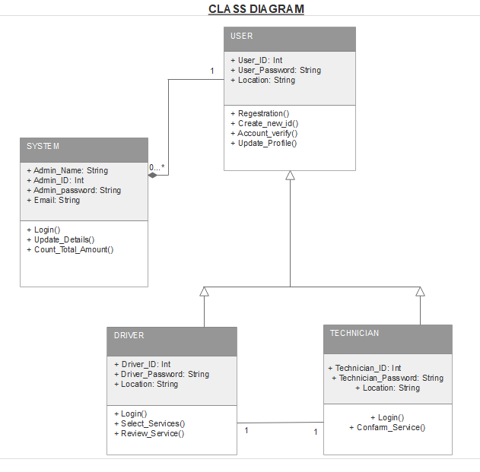

**CLASS COMPARTMENT:**